**Framework Configuration document**

**Step 1**

1. **Download and install Java using the below link**

<https://www.oracle.com/java/technologies/downloads/>

1. **Add java to the environment variables**
2. Enter the Environment variables in Cortana

Click and open

1. Open System Properties and select Environment Variables under the Advanced tab

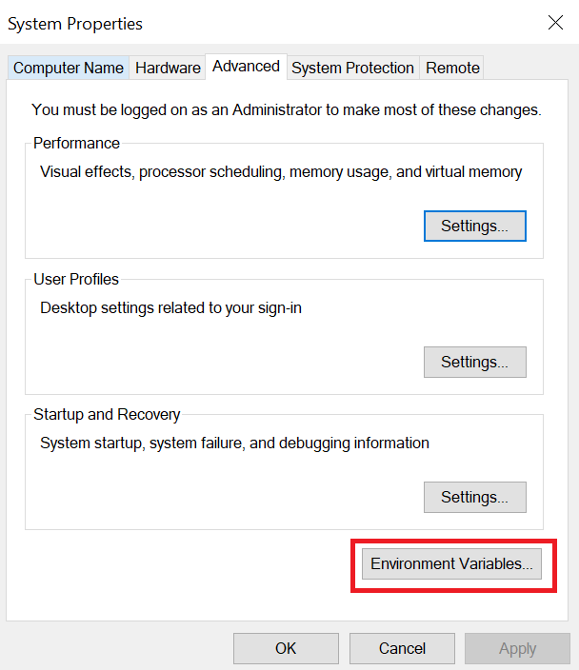

b. Under System variables select path and click edit

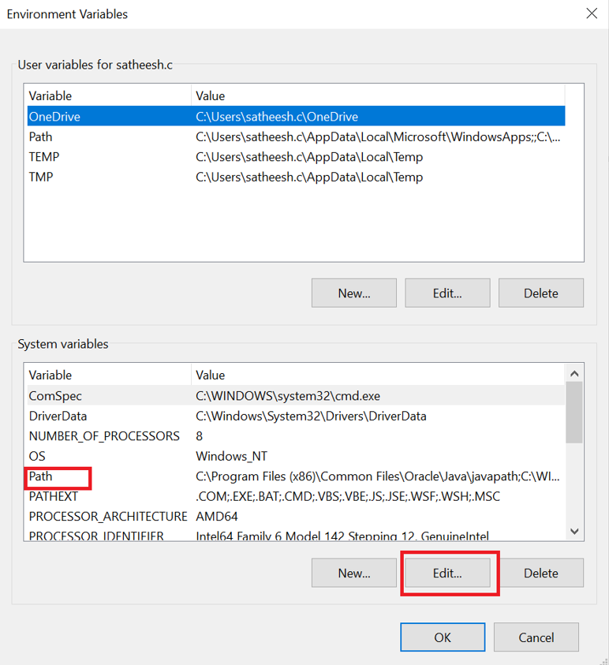

c. Click New

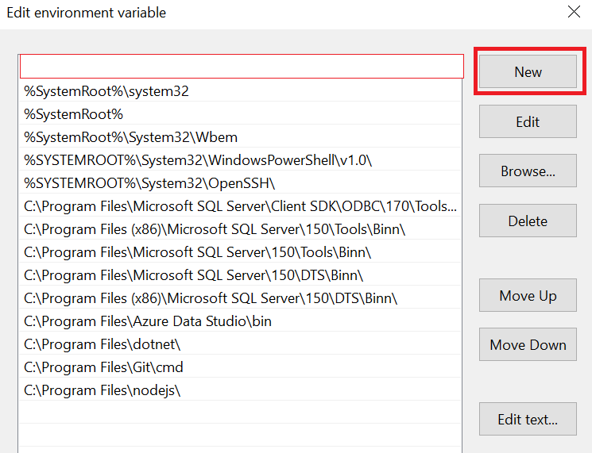

d.Copy the Java path and paste it and click ok and Apply

e. And it will appear like below image (path may be different as per your local system)

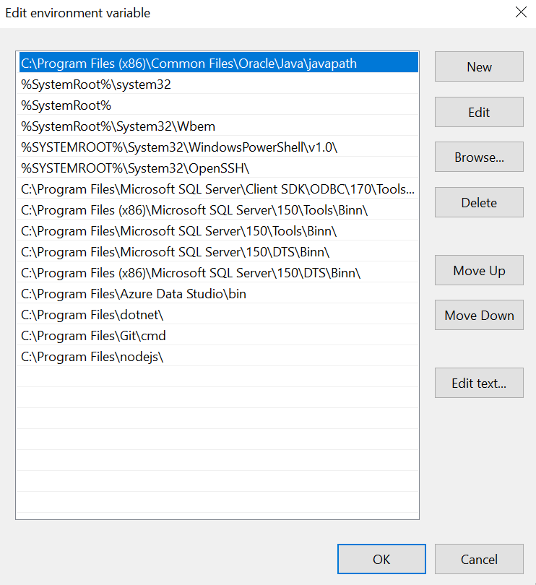

**Step 2**

**Download Git using below link as per your system specifications**

<https://git-scm.com/download/win>

**Step 3**

**Download and install Eclipse IDE using the below link as per your system configuration**

<https://www.eclipse.org/downloads/>

**Step 4**

**Clone the project into the local machine from the Azure repo**

1. Create the folder in the local system and go to folder path and enter ‘cmd’ and press enter

And command prompt will open

Enter the **git init** command and press enter

You will get a below message

Initialized empty Git repository in C:/Users/satheesh.c/AutomationDocument/.git/

1. Go to Azure Repo
2. Select the ‘HUB-TestAutomation’ from the dropdown

1. Click the Clone in the left

1. Copy the **HTTPS** Url by clicking the copy icon

1. Go back to command prompt

Enter **git clone** <https://HungerRush@dev.azure.com/HungerRush/ReventionMain/_git/HUB-TestAutomation>

and press enter

The project will cloned into your local machine

Now verify it in the local folder whether the project got downloaded

**Step 5**

**Import the cloned project into the Eclipse IDE**

1. Open the Eclipse and click the File in the Menu bar

1. Click Import
2. Enter the ‘Maven’ in the text box

1. Choose ‘Existing Maven Projects’ and Click ‘Next’

1. Click the Browse and select the recently cloned project

1. Select the folder and click next and finish

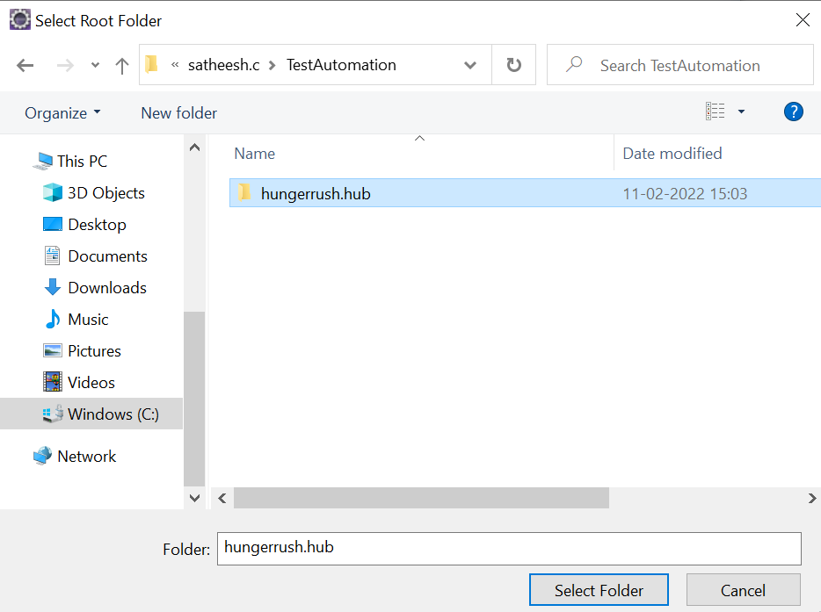

1. And it will imported to your eclipse please wait for some time to build the project set up. Once it is over the project will appear like below in the package explorer

1. Right click on the testing.xml file in the package explorer and select ‘Run As’ then click ‘TestNG Suite’

Now the suite will launch the browsers and execute the test cases

**Step 6**

**Install the testing plugin from the eclipse marketplace**

1. Go to Help in the menu bar and then navigate to Eclipse Marketplace and select 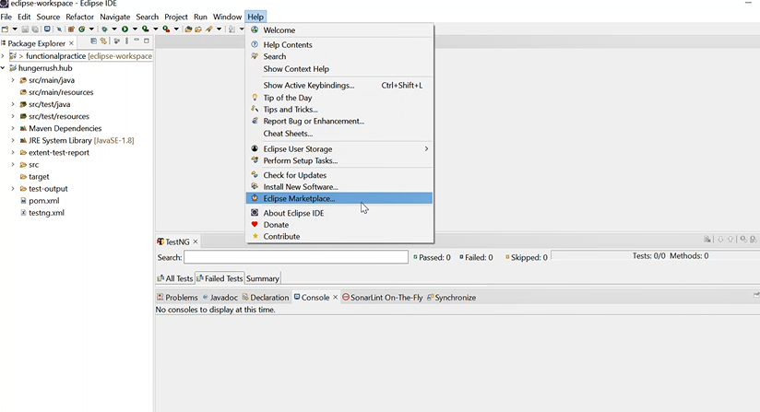
2. Enter ‘Testng’ in the find bar and click enter

1. Click the install and Testng will get installed and restart the eclipse(normally eclipse automatically will ask for the restart otherwise please do it manually)

